CPE301 – SPRING 2019

Design Assignment X

Student Name: Tian Chen

Student #: 2001086575

Student Email: chent5@unvl.nevada.edu

Primary Github address: <https://github.com/Chentian12138/AAAABBBBB>

Directory:DA3

Submit the following for all Labs:

1. In the document, for each task submit the modified or included code (only) with highlights and justifications of the modifications. Also, include the comments.
2. Use the previously create a Github repository with a random name (no CPE/301, Lastname, Firstname). Place all labs under the root folder ESD301/DA, sub-folder named LABXX, with one document and one video link file for each lab, place modified asm/c files named as LabXX-TYY.asm/c.
3. If multiple asm/c files or other libraries are used, create a folder LabXX-TYY and place these files inside the folder.
4. The folder should have a) Word document (see template), b) source code file(s) and other include files, c) text file with youtube video links (see template).

1. **COMPONENTS LIST AND CONNECTION BLOCK DIAGRAM w/ PINS**

FTDI chip and atmega328p X plained mini chip

1. **INITIAL/MODIFIED/DEVELOPED CODE OF TASK 1/A**

/*

* DA3.c

*

* Created: 3/27/2019 9:21:51 PM

* Author : chent

*/

#define *F_CPU* 16000000UL

#define BAUDRATE 9600

#define BAUD_PRESCALLER (((*F_CPU* / (BAUDRATE * 16UL))) - 1)

#include <avr/io.h>

#include <avr/interrupt.h>

#include <stdio.h>

#include <util/setbaud.h>

void USART_init( unsigned int ubrr ); // initializes analog to digital

void USART_tx_string(char*data); // prints a string

int ranNumber = 4; // declare a random number

volatile float ranFloat = 5.5648965; // declare random float

char outs[20]; // allocate memory space for float

int main(void)

{

USART_init(BAUD_PRESCALLER); // Initialize the USART

TCCR1B |= (1<<CS12) | (1<<CS10); // set prescaler = 1024

TIMSK1 = (1<<TOIE1); // enable overflow flag

TCNT1 = 75001; // reset timer (65535 - 15624)

sei(); // enable interrupts

while (1) {} // wait for timer interrupt

}

ISR (TIMER1_OVF_vect)

{

USART_tx_string("\n"); // start

USART_tx_string("This is a string"); // print string

USART_tx_string("\n"); // got to next one

*snprintf*(outs, sizeof(outs), "%3d\r\n", ranNumber); // print int

USART_tx_string("\n"); // go to next one

*sprintf*(outs, "%g", ranFloat);

USART_tx_string(outs); // print float

USART_tx_string("\n"); // start over

TCNT1 = 75001; // reset timer

}

/* INIT USART (RS-232) */

void USART_init( unsigned int ubrr )

{

UBRR0H = (unsigned char)(ubrr>>8);

UBRR0L = (unsigned char)ubrr;

UCSR0B = (1 << TXEN0); // Enable RX, TX & RX interrupt

UCSR0C = (3 << UCSZ00); //asynchronous 8 N 1

}

/* SEND A STRING THROUGH RS-232 BY FTDI BOARD*/

void USART_tx_string( char *data )

{

while ((*data != '\0'))

{

while (!(UCSR0A & (1 <<UDRE0)));

UDR0 = *data;

data++;

}

}

1. **SCHEMATICS**

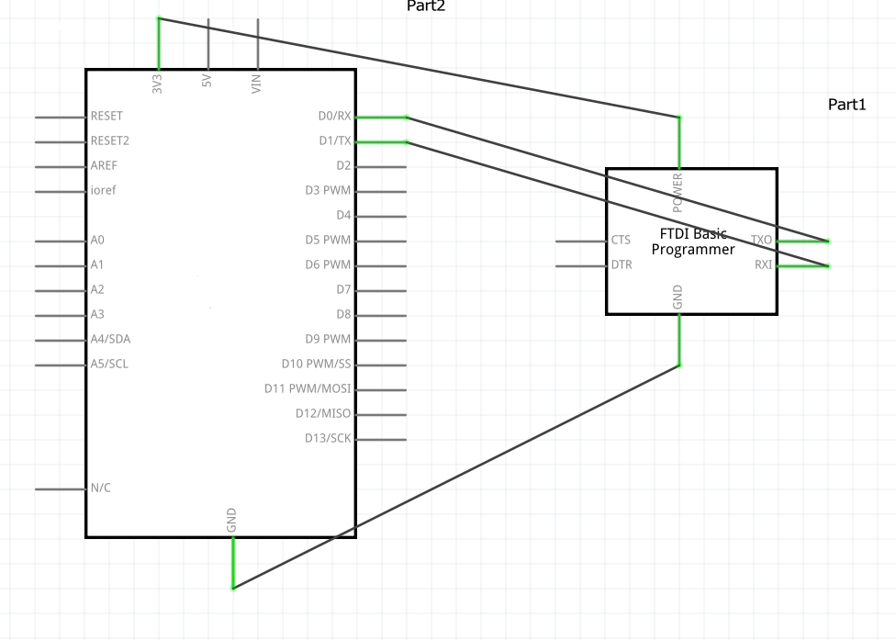

1. **SCREENSHOTS OF OUTPUT**

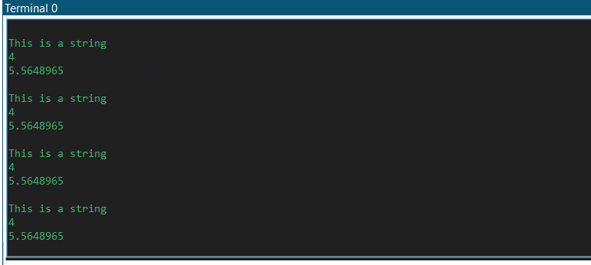

1. **SCREENSHOT OF EACH DEMO (BOARD SETUP)**

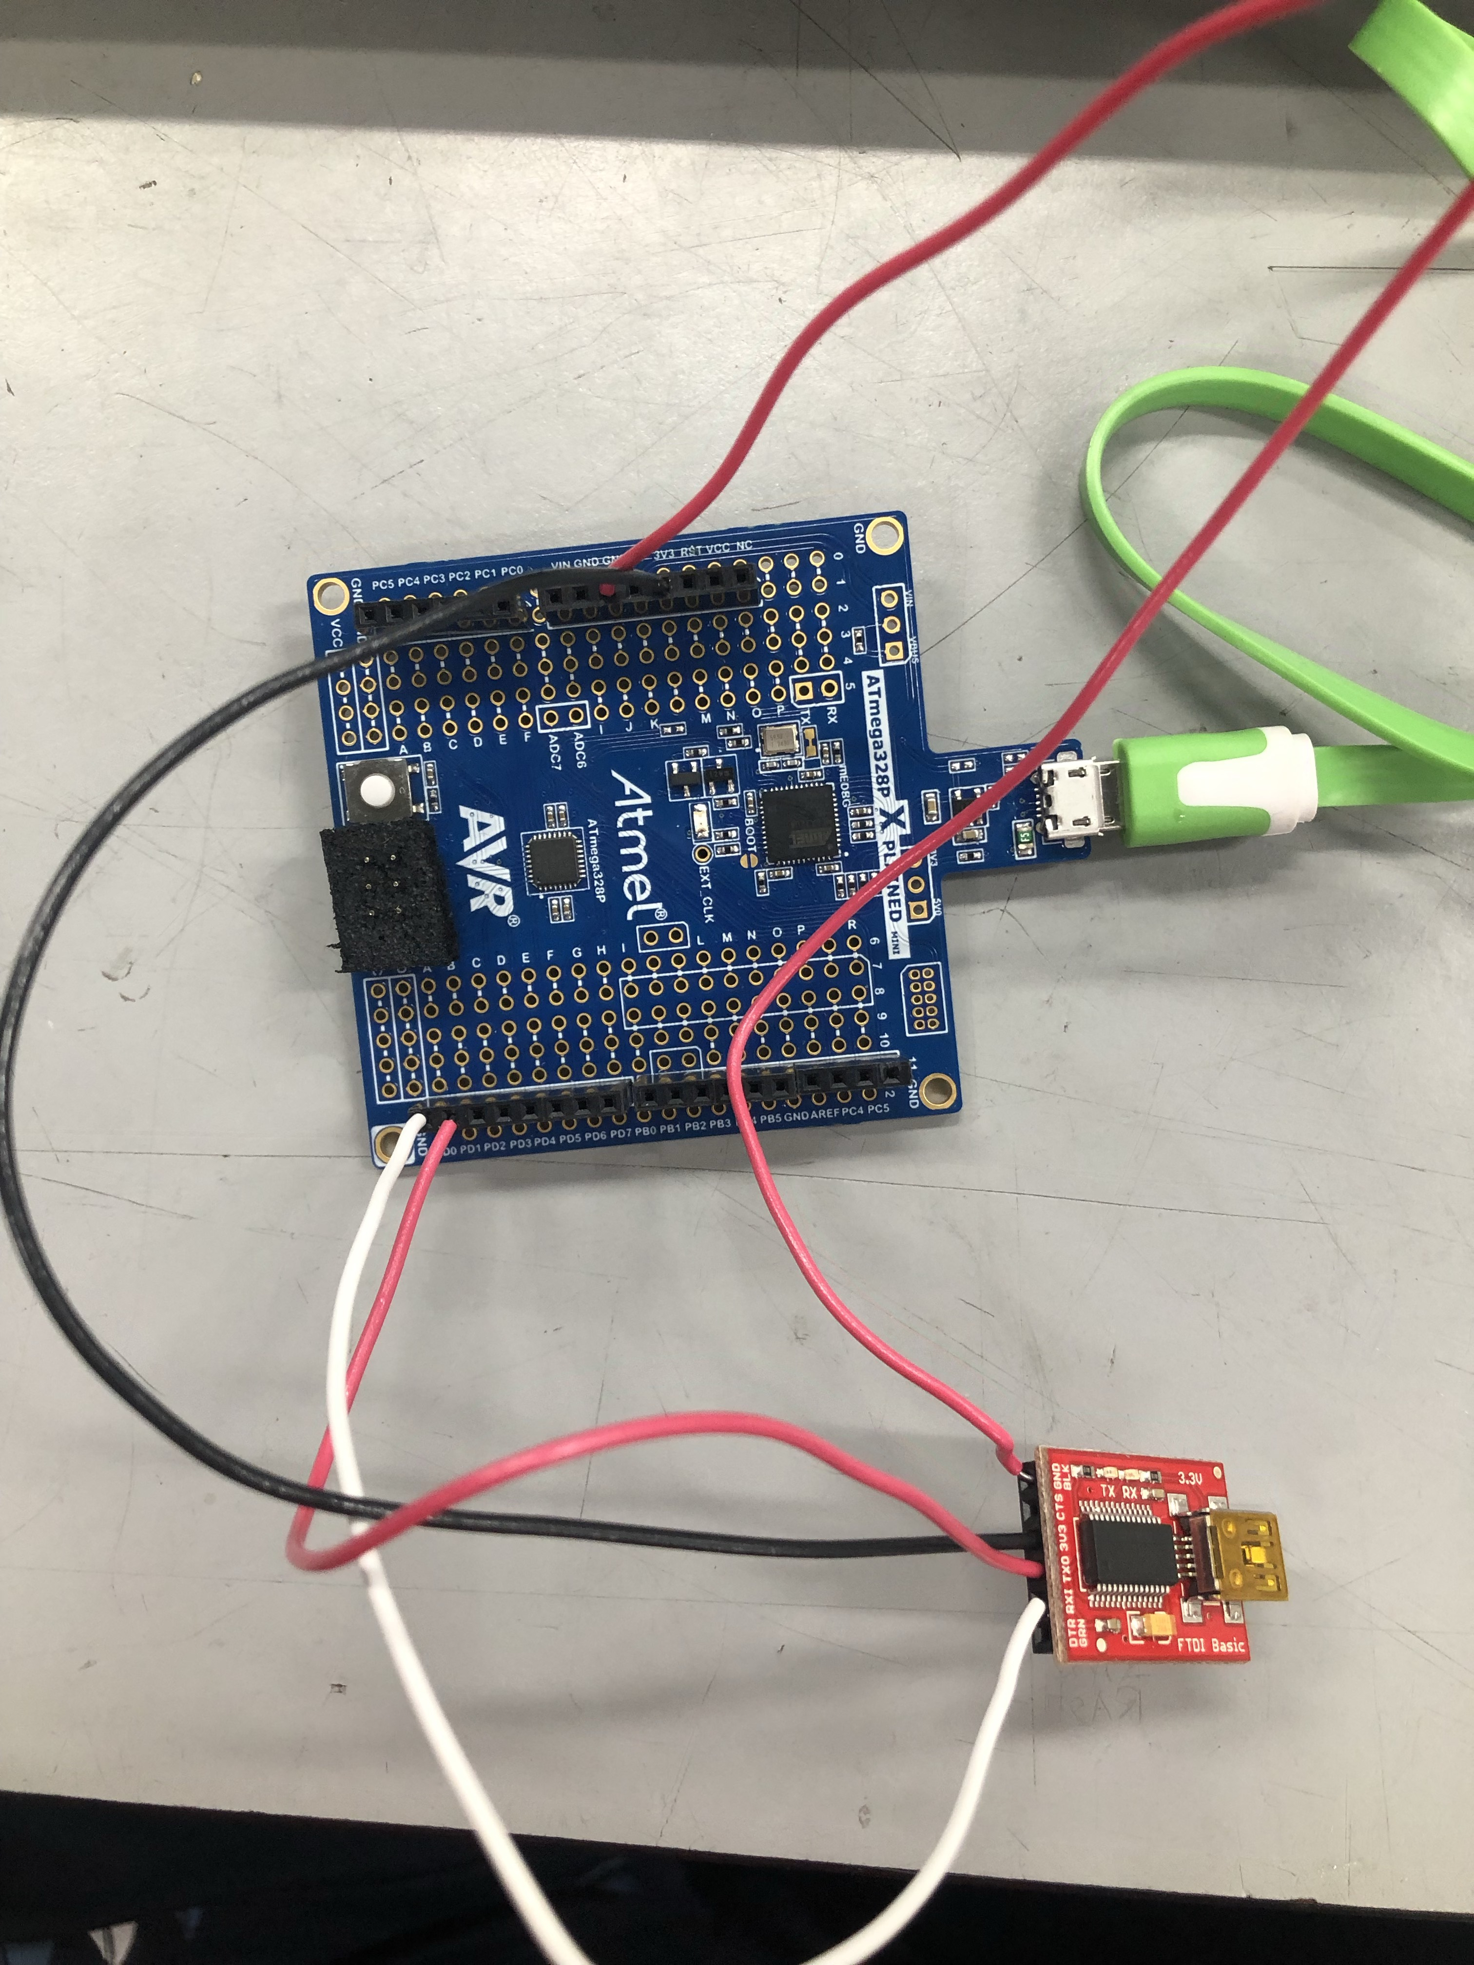

1. **GITHUB LINK OF THIS DA**

x

**Student Academic Misconduct Policy**

<http://studentconduct.unlv.edu/misconduct/policy.html>

“This assignment submission is my own, original work”.

NAME OF THE STUDENT